Building Composable Commerce at Scale: Inside the NuMart Reference Platform

Table of Contents
I. Introduction 4
II. Business Objectives 4
III. Platform Overview 4
A. MS Accelerator 4
B. DataWise PIM 5
IV. Architecture Overview 5
Key Architectural Principles 6
V. Deployment Approaches 6
A. Serverless (Default Approach) 6
B. Cluster Deployment 6
VI. Backend Technology Stack 6
A. Core Technologies 6
B. Communication Model 7
VII. Microservices Landscape 7
Core Services 7
VIII. Content Management System (CMS) 7
Supported CMS Platforms but not limited to 8
Key Capabilities 8
Cache Strategy 8
IX. Search & Filtering 8
Primary Search Engine used 8
Search Workflow 8
Alternative Search Engines 8
X. Product Detail Page (PDP) 8
Core PDP Features 8
Advanced Capabilities 9
XI. Checkout Experience 9
Address Management 9
Payment Integrations 9
XII. Customer Account Management 9
Account Features 9
XIII. Non-Functional Capabilities 10
Scalability 10
Availability 10
Performance 10
Security 10
XIV. Key Benefits of NuMart Architecture 10
XV. Conclusion 10

Introduction
NuMart is a demo eCommerce application designed to showcase the capabilities of MS Accelerator (Microservices Accelerator) and DataWise PIM platforms built by NULogic. It demonstrates the modernness of cloud-native, API-first, and composable commerce architecture that can be built to support scalability, flexibility, and rapid innovation.
NuMart follows microservices and headless principles, enabling enterprises to:
- Scale individual business capabilities independently.
- Integrate best-of-breed SaaS tools.
- Achieve high availability with zero downtime.
- Reduce time-to-market for new features.

Business Objectives
NuMart is designed to address common enterprise commerce challenges:
- Monolithic platform limitations
- Slow release cycles
- Tight coupling between frontend and backend
- Inflexible CMS and search capabilities
- Difficulty scaling during peak traffic
Primary goals:
- Modular architecture with independent deployments
- API-driven integrations
- Cloud-native scalability
- Vendor-agnostic technology choices
- Improved performance and customer experience

Platform Overview
NuMart is built on two core platforms:

MS Accelerator
A microservices accelerator framework that provides:
- Standardized service templates
- API orchestration patterns
- Observability and monitoring hooks
- Security and identity patterns
- Deployment flexibility (Serverless or VM-based)

DataWise PIM
A Product Information Management (PIM) platform responsible for:
- Centralized product data management
- Product enrichment
- Attribute modeling
- Data syndication to search, CMS, and commerce services

Architecture Overview
NuMart adopts a Microservices Architecture with a headless frontend and API-driven backend.
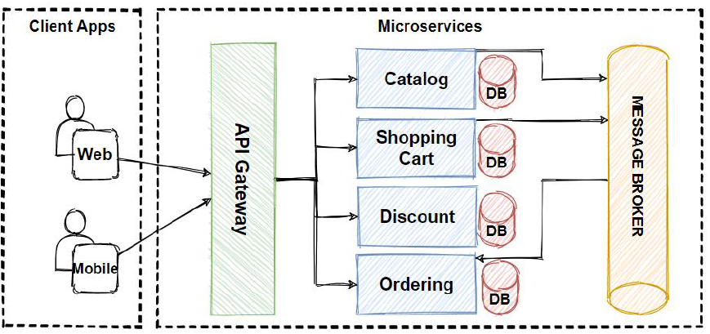
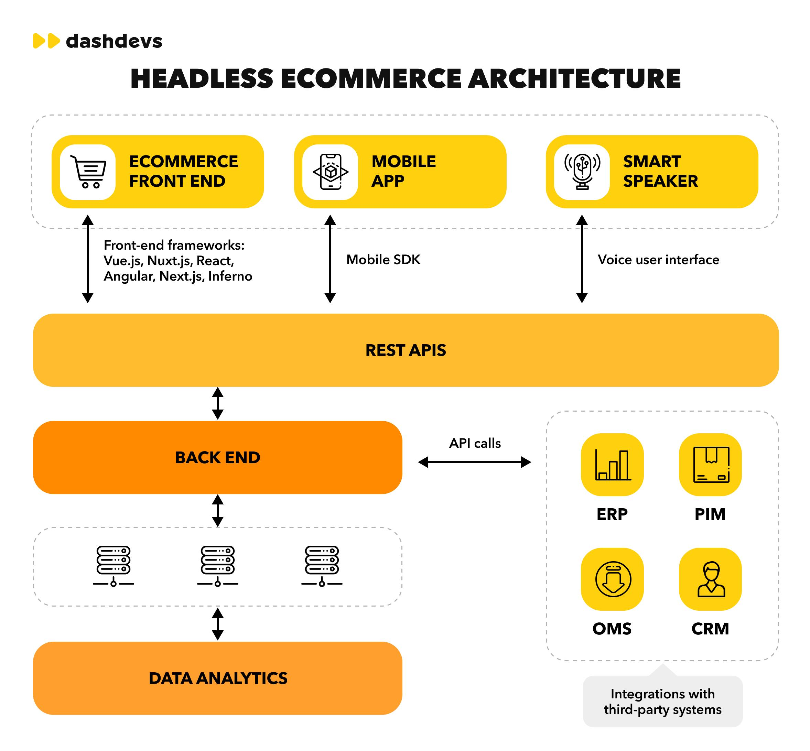

Key Architectural Principles
- Domain-driven service separation
- Stateless services
- Event-ready architecture
- Cloud-agnostic design
- Horizontal scalability

Deployment Approaches
NuMart supports two deployment strategies, allowing enterprises to choose based on maturity, cost, and compliance needs.

Serverless (Default Approach)
- AWS Lambda/Google Functions for microservices
- API Gateway / GraphQL Gateway
- Auto-scaling by default
- Pay-per-use cost model
- Ideal for variable traffic and rapid scaling
Benefits
- No infrastructure management
- Built-in fault tolerance
- Faster provisioning

Cluster Deployment
- Services deployed on clusters.
- Six-node cluster for high availability
- Containerized or process-based services
- Suitable for long-running workloads
Benefits
- Predictable cost model
- Full infrastructure control
- Easier legacy integration

Backend Technology Stack

Core Technologies
- Node.js – Runtime environment
- Express.js – REST and middleware handling
- GraphQL – Unified API layer for frontend consumption

Communication Model
- Frontend communicates via GraphQL
- GraphQL aggregates responses from multiple microservices
- Internal service-to-service communication via APIs/events
- Frontend Technology Stack
  - Core Technologies
- Node.Js - Runtime environment
- Next Js - ReactJs Framework
- SCSS

Microservices Landscape
Each business capability is implemented as an independent microservice.

Core Services
Service | Responsibility
Cart | Cart creation, updates, promotions
Item | Product SKU handling
Inventory | Stock availability and reservations
Identity | Authentication, authorization
Order | Order creation and lifecycle
Payment | Payment initiation and status handling
Each service can be:
- Independently deployed
- Independently scaled
- Independently versioned

Content Management System (CMS)
NuMart follows a headless CMS approach, enabling content to be managed independently from presentation.

Supported CMS Platforms but not limited to
- Contentful
- Sanity
- Bloomreach

Key Capabilities
- API-driven content delivery
- Independent CMS SLA
- CDN-level caching
- Zero downtime publishing

Cache Strategy
- Content cached at CDN or server layer
- Cache invalidation triggered only during CMS updates
- Ensures high performance with fresh content delivery

Search & Filtering
NuMart integrates best-in-class search engines for fast and accurate discovery.

Primary Search Engine used
- Algolia

Search Workflow
  - Product data exported from DataWise PIM
  - Indexed in Search Engine
  - Real-time search and filtering on frontend

Alternative Search Engines
  - Bloomreach Search
  - Elasticsearch
  - Google Retail Search
This design ensures vendor independence and future extensibility.

Product Detail Page (PDP)

Core PDP Features
  - Product details
  - Add-to-Cart (ATC)
  - Pricing and availability
  - Media and attributes

Advanced Capabilities
  - Cross-sell and Upsell recommendations
  - Review integration (e.g., Power Reviews)
  - Personalized recommendations
All integrations are pluggable, allowing easy replacement of vendors.

Checkout Experience
NuMart provides a fast and flexible checkout flow.

Address Management
  - Google Address Autocomplete
  - Experian Address Validation

Payment Integrations
  - Apple Pay
  - PayPal
  - Credit Card / Debit Card
  - Klarna and other buy-now-pay-later providers
The payment service abstracts providers, enabling:
  - Easy addition/removal of gateways
  - Regional payment customization

Customer Account Management

Account Features
  - Profile management
  - Address book (Add/Edit/Delete)
  - Order history
  - Recently Viewed products
  - Secure authentication
Account services integrate seamlessly with Identity and Order services.

Non-Functional Capabilities

Scalability
  - Horizontal scaling per service
  - Auto-scaling (serverless)

Availability
  - Zero downtime deployments
  - Fault isolation per service

Performance
  - CDN caching
  - Optimized GraphQL aggregation
  - Search offloaded to dedicated engines

Security
  - Token-based authentication
  - Service-level authorization
  - Secure payment handling

Key Benefits of NuMart Architecture
- MACH-aligned (Microservices, API-first, Cloud-native, Headless)
- Vendor-agnostic and future-proof
- Faster innovation cycles
- Enterprise-grade scalability
- Reduced operational risk

Conclusion
NuMart serves as a reference implementation showcasing how modern enterprises can build a scalable, composable, and resilient commerce platform using MS Accelerator and DataWise PIM.
It demonstrates that eCommerce platforms no longer need to be monolithic. Instead, they can be assembled, evolved, and optimized using best-of-breed technologies aligned with business growth.

